I B Tech, I Sem
LINEAR ALGEBRA & CALCULUS (R-23)
(COMMON TO ALL BRANCHES)
QUESTION BANK (2Marks with Answers) 2023-2024
S.NO | QUESTIONS | CO | BL
Module-1
MATRICES
1 | Define rank of a matrix.  Ans: - A matrix is said to be of rank ‘r’ when  (i) It has at least one non-zero minor of order r and  (ii) every minor of order higher than ‘r’ vanishes. | 1 | 1
2 | Explain diagonal matrix with suitable examples.  Ans: - A square matrix in which every element except the principal diagonal elements is zero is called a Diagonal Matrix.  Eg: - 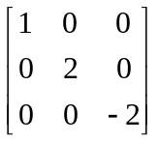 | 1 | 2
3 | Define singular and non-singular matrices.  Ans: - A singular matrix has a determinant value equal to zero, and a non-singular matrix has a determinant whose value is a non-zero value. The singular matrix does not have an inverse, and only a non-singular matrix has an inverse matrix. | 1 | 1
4 | Define symmetric and skew-symmetric matrices.  Ans: - A symmetric matrix and skew-symmetric matrix both are square matrices. But the difference between them is, the symmetric matrix is equal to its transpose whereas skew-symmetric matrix is a matrix whose transpose is equal to its negative.  If A is a symmetric matrix, then A = A^{T} and if A is a skew-symmetric matrix then A^{T} = – A. | 1 | 1
5 | Define zero row and non-zero row.  Ans: - If all the elements in a row of a matrix are zeros, then it is called a zero row and if there is at least one non-zero element in a row, then it is called a non-zero row. | 1 | 1
6 | Obtain the rank of the matrix 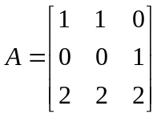  Ans: - 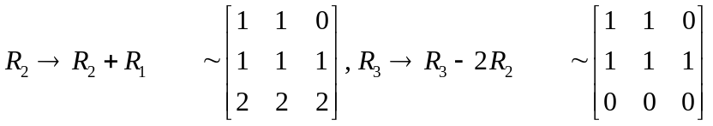  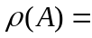Number of non-zero rows = 2. | 1 | 1
7 | Find the rank of the matrix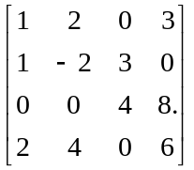  Ans: - 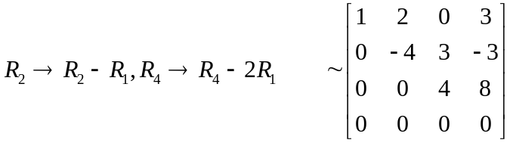  Number of non-zero rows = 3. | 1 | 1
8 | Explain the Echelon form of a Matrix.  Ans: - A matrix A is said to be in Echelon form if  (i) All the non-zero rows, if any precede the zero rows.  (ii) The number of zeros preceding the first non - zero element in a row is less than the number of such zeros in the succeeding rows.  (iii) The first non-zero element in a row is unity. (If it is possible )  (iv) We can reduce the given matrix to the echelon form by elementary row transformations only. “The number of non- zero rows in the echelon form is the rank of the matrix. | 1 | 2
9 | Obtain the rank of the matrix 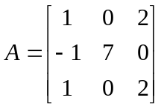  Ans: - 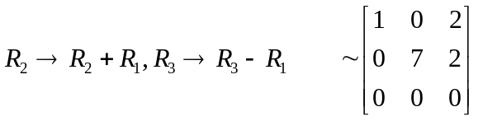  Number of non-zero rows = 2. | 1 | 1
10 | Obtain the rank of the matrix 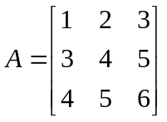  Ans: - 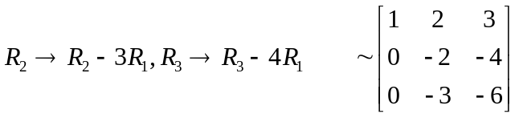  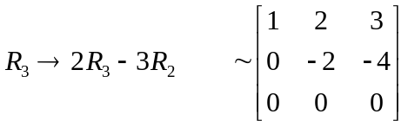  Number of non-zero rows = 2. | 1 | 1
11 | Calculate the rank of the matrix 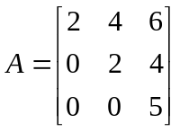  Ans: - Number of non-zero rows = 3. | 1 | 1
12 | Obtain the rank of the matrix 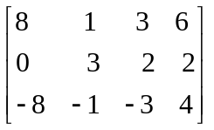  Ans: - 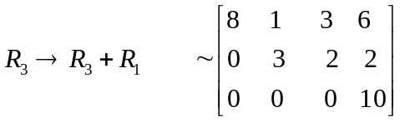  Number of non-zero rows = 3. | 1 | 1
13 | Explain the normal form of a Matrix.  Ans: - The Normal form of the matrix as follows:  Every non zero matrix A of rank ‘r’, can be reduced by a sequence of elementary transformations, to any of the form 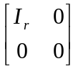,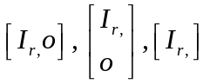are called as the normal forms of a matrix A. | 1 | 2
14 | State Cauchy–Binet formulae.  Ans: - The Cauchy–Binet formula, is an identity for the determinant of the product of two rectangular matrices of transpose shapes (so that the product is well-defined and square). | 1 | 1
15 | Explain the working rule for finding the Inverse of a matrix by Gauss-Jordan method  Ans: - Suppose A is non-singular square matrix o order n. We write 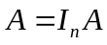  Now, apply elementary row operations only to the matrix A and prefactor 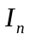of the R.H.S. we will do this till we get an equation of the form 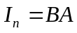  Then obviously B is the inverse of A. | 1 | 1
16 | Define system of linear equations with suitable example.  Ans: - The system of linear equations is the set of two or more linear equations involving the same variables. Here, linear equations can be defined as the equations of the first order, i.e., the highest power of the variable is 1. Linear equations can have one variable, two variables, or three variables. Thus, we can write linear equations with n number of variables.  Let a₁₁x₁ + a₁₂x₂ + a₁₃x₃ + …. + a_{1n}x_{n} = b₁  a₂₁x₁ + a₂₂x₂ + a₂₃x₃ + …. + a_{2n}x_{n} = b₂  …………………………………..  …………………………………..  a_{n1}x₁ + a_{n2}x₂ + a_{n3}x₃ + …. + a_{nn}x_{n} = b_{n} be a system of “n” linear equations in “n” variables x₁, x₂, x₃,…., x_{n}. Where, a₁₁, a₁₂, …, a₂₁, a₂₂,…, a_{n1}, a_{n2},…, a_{nn} are the coefficients of variables, x₁, x₂,…., x_{n}.  Eg:- | 1 | 1
17 | Explain the nature of solution of the system of homogeneous linear equation.  Ans: - To find the rank of the coefficient matrix A by reducing it to the Echelon form by elementary row operations.  (i) If rank of A(r) = n (no. of unknowns) then the system has a trivial solution. i.e. x₁ = x₂ =………….= x_{n} = 0  (ii) If r < n, the system has non trivial solution and (n- r) linearly independent solutions. | 1 | 2
18 | Define augmented matrix  Ans: - An augmented matrix is a means to solve simple linear equations. The coefficients and constant values of the linear equations are represented as a matrix, referred to as an augmented matrix. In simple terms, the augmented matrix is the combination of two simple matrices along the columns. If there are m columns in the first matrix and n columns in the second matrix, then there would be m + n columns in the augmented matrix. | 1 | 1
19 | Define: (i) consistent (ii) inconsistent  Ans: - In non-homogeneous system of equations, let AX=B be the given system in matrix form. If 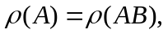then the system is said to be consistent and it has a solution otherwise the system is inconsistent and it has no solution. | 1 | 1
20 | Explain the nature of solution of the system of non- homogeneous linear equation.  Ans: - Find the ranks of the coefficient matrix A and the augmented matrix [AB], by reducing [AB] to the Echelon form by elementary row operations. Let the rank of A be ‘r’ and that of [AB] be r¹.  (i) If r ≠ r¹ the system is inconsistent, there is no solution  (ii) If r = r¹ = n, the system is consistent, there is unique solution  (iii) If r = r¹< n, the equations are consistent and there are infinite number of solutions. | 1 | 2
Module-2
Eigenvalues, Eigenvectors and Orthogonal Transformation
1 | Find the characteristic roots of the matrix 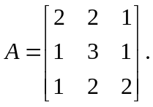  Ans: - The characteristic equation of A is, |A-λI|=0  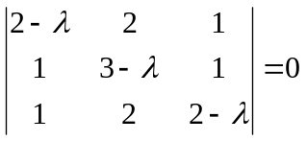  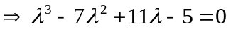  On simplifying, we get 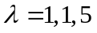  The characteristic roots are 1, 1, 5 | 2 | 1
2 | Find the Eigen values of 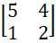  Ans: - The characteristic equation of A is, |A-λI|=0  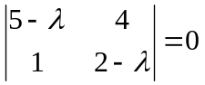  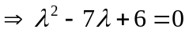  On simplifying, we get 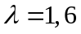  The eigen values are 1, 6 | 2 | 1
3 | Find the characteristic roots of the matrix 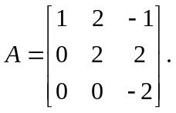  Ans: - The characteristic equation of A is, |A-λI|=0  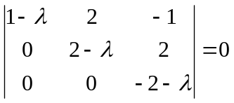  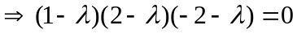  On simplifying, we get 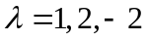  The characteristic roots are 1, 2, -2 | 2 | 1
4 | Find the characteristic polynomial of the matrix 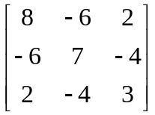.  Ans: - The characteristic equation of A is, |A-λI|=0  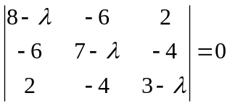  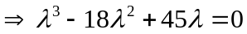  The characteristic polynomial is 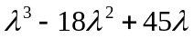 | 2 | 1
5 | Find the characteristic polynomial of the matrix 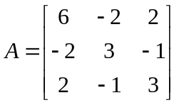.  Ans: - The characteristic equation of A is, |A-λI|=0  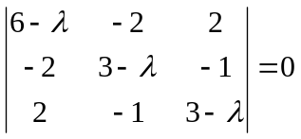  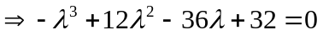  The characteristic polynomial is 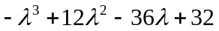 | 2 | 1
6 | Find the sum and product of the eigen values of 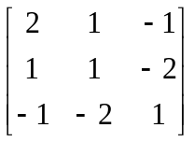  Ans: - The characteristic equation of A is, |A-λI|=0  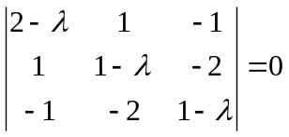  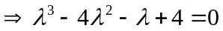  On simplifying, we get 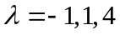  The eigen values are -1, 1, 4  The sum of the eigen values=-1+1+4=4  The product of the eigen values=(-1)(1)(4)= -4 | 2 | 1
7 | Find the sum and product of the eigen values of 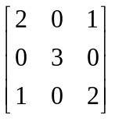  Ans:- The characteristic equation of A is, |A-λI|=0  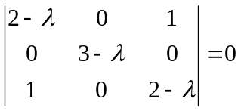  On simplifying, we get  The sum of the eigen values=7  The product of the eigen values=9 | 2 | 1
8 | Find the eigen values of the unit matrix of order 3.  Ans: - Consider the unit matrix of order 3 is, 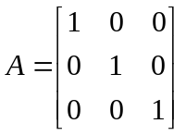  The characteristic equation of A is, |A-λI|=0  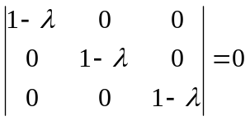  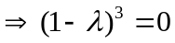  On simplifying, we get 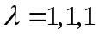  The eigen values are 1, 1, 1. | 2 | 1
9 | Define eigen value and eigen vector of a Matrix.  Ans: - If A is any square matrix of order ’n’ we can form the matrix 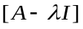where I is the nth order unit matrix. The determinant of this matrix equated to zero i.e., |A-λI|=0. The roots of this characteristic equation are characteristic roots (or eigen values) of A.  Let A be a square matrix and any non-zero vector X is said to be eigen vector of A, if there exists a number such that 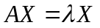, then is said to be eigen root of the matrix corresponding to X and X is said to be eigen vector corresponding to . | 2 | 1
10 | Define Characteristic equation and Characteristic roots of a matrix.  Ans: - If A is any square matrix of order ’n’ we can form the matrix where I is the nth order unit matrix. The determinant of this matrix equated to zero i.e.  |A-λI|= 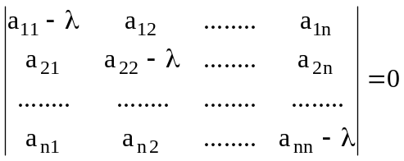  The roots of this characteristic equation are characteristic roots of A. | 2 | 1
11 | Find the eigen vector of corresponding to 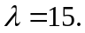  Ans: 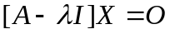  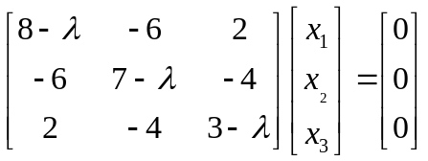  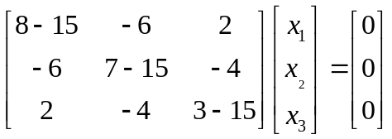  On simplifying, we get  Eigen vector,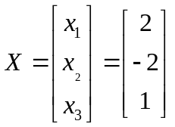 | 2 | 1
12 | Find the eigen vector of 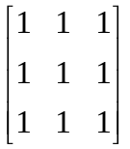corresponding to 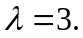  Ans:  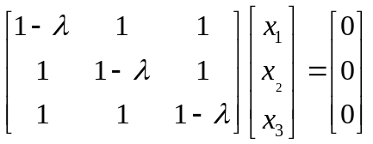  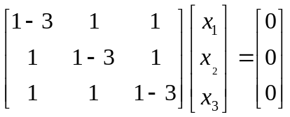  On simplifying, we get  Eigen vector,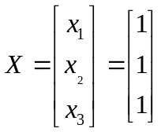 | 2 | 1
13 | If 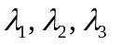are the eigen values of 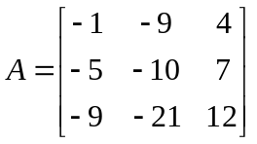, then find 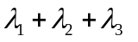  Ans: - The characteristic equation of A is, |A-λI|=0  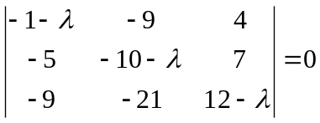  On simplifying, we get  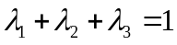 | 2 | 1
14 | Define diagonal matrix.  Ans: - A square matrix in which every element except the principal diagonal elements is zero is called a Diagonal Matrix. | 2 | 1
15 | Explain the working rule of diagonalization form.  Ans: - Diagonalization as follows:  - Any two matrices A and B which are related by a relation B=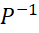AP where P is any nonsingular matrix then A,B are said to be similar.  - If a square matrix A of order n has n linearly independent eigen vectors then there exists a non-singular matrix P such that AP is a diagonal matrix i.e.,AP=D, whose diagonal elements are eigen values of A.  - Where P is the modal matrix formed by grouping the eigen vectors of A as columns. | 2 | 2
16 | If 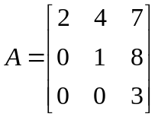, then find the eigen values of 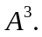  The characteristic equation of A is, |A-λI|=0  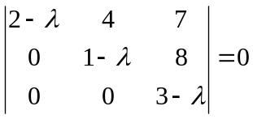  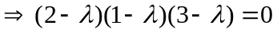  On simplifying, we get 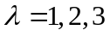  The eigen values are 1, 2, 3  The eigen values of 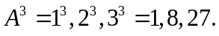 | 2 | 1
17 | State Cayley Hamilton theorem.  Ans: - Every square matrix satisfies its own characteristics equation. | 2 | 1
18 | If 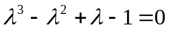is the characteristic equation of A, then find 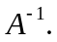  Ans: - By using Cayley-Hamilton theorem,  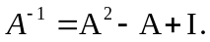 | 2 | 1
19 | What is the nature and signature of the quadratic form.  Ans: - The Nature of a quadratic form as follows:  A real quadratic form in n variables is said to be  Positive definite: If all the Eigen values are positive  Negative definite: If all the Eigen values are negative  Positive semi-definite: If at least one Eigen value is zero and the remaining Eigen values are positive  Negative semi-definite: If at least one Eigen value is zero and all other Eigen values are negative  Indefinite: If some of the Eigen values are positive and some are negative | 2 | 1
20 | Write the quadratic form of the matrix A =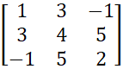.  Ans: - Given that, A =  The quadratic form of the matrix A is, x² +4y² +2z²+6xy+10yz-2zx | 2 | 1

Sign. of Course Co-ordinator Sign. of HoD

